INSTRUCTIONS
First, think about the resources, constraints, and assumptions you have about this project. Use this information to help you come up with your goals. Write all of them down in the table on the next page.

Project Resources are what you can use to research, design, and create your city. People to ask for advice; skills you, your team, and your mentor can offer; and equipment and supplies from school or home go in this section.

Constraints are what limit your options on this project. You only have a certain amount of time, money, and expertise, for example. Do you have enough computers? Are the competition rules posing restrictions? What about the requirements of each deliverable? The size of your group? List constraints in this section and include ways to work around as many of these constraints as you can think of.

Assumptions: What are you pretty sure is true about this project? In this section, you write down things like how much time you think you have, what materials you know you can get a hold of, how you think your group will work together, and what you assume will be difficult to accomplish.

Project goals describe what you hope to achieve for the project (rather than for your city). Knowing what your resources, constraints, and assumptions are can help you pick project goals. Project goal examples include coming in under budget, hitting your due dates, and working well as a team.

Use the space below to brainstorm ideas, and write your final thoughts in the chart on the next page.

FUTURE CITY TEAM NAME:

ORGANIZATION/SCHOOL:

EDUCATOR:

List resources, constraints, assumptions, and goals for your project below.

Our project resources:

Constraints on our project:

Assumptions we have about our project:

Our goals for this project (pick at least two more goals):
1. Our team will successfully create an age-friendly city.

2.

3.

4.

INSTRUCTIONS
To create your schedule, figure out what needs to be done and in what order. Follow the process outlined here or use your own.

Step 1: List Tasks for Each Deliverable

Begin by brainstorming tasks for each deliverable. Write them on index cards or sticky notes. You can color code them so that everything to do with one deliverable, such as the City Essay, is one color, whereas everything to do with the City Model is another. If each task is on its own card, it’s easy to move them around as the schedule changes.

Step 2: Put Tasks in Order

Now it’s time to think about the sequences in which things should be done. Arrange the cards for each deliverable in a logical order

Step 3: Estimate Time Each Task Takes

Think about how much time tasks will take. You can’t know exactly, but make your best guess. Write this in pencil on each task card, so that it’s easy to erase and change if the task takes less or more time than you thought.

Step 4: Assign Roles

Next, decide who will get the work done. Assign team members to be responsible for each task and record their names on the cards.

Step 5: Make a Schedule

On a bulletin board, white board, or chart paper on the wall, create a giant schedule that you can task the cards on. Things will change along the way – so make sure you can make changes easily in order to revise your schedule.

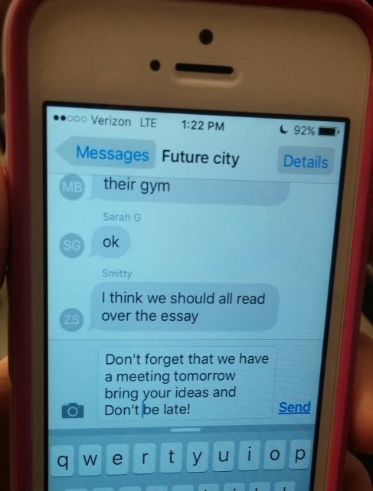
Show Us Your Style!

An image of your schedule is part of your Project Plan deliverable. What does your schedule look like? Is it a large wall calendar, shared online calendar, or something else?

FUTURE CITY TEAM NAME:

ORGANIZATION/SCHOOL:

EDUCATOR:

Instructions: In the space below, insert a photo, drawing, sample planning text message – anything that captures how your team scheduled your project.

TEAM SCHEDULE

INSTRUCTIONS

Check-ins with teammates and your educator help you monitor progress and ensure that you’re meeting deadlines. Most of these check-ins can be quick conversations. But one of them needs to be written down as part of your Project Plan deliverable. Part 3 of your Project Plan is where to put this written check-in.

You can also make copies of the Check-In Report template and use it to update all the project stakeholders (team members, educator, and mentor) on the status of your Future City project as often as you want.

Tip: Before Each Check-In:

- Review your schedule and the requirements for each deliverable.

After Each Check-In:
- Make changes to your schedule as needed.

Show Us Your Style!
Submit one report that illustrates an important point in your project, such as when you solved a problem, made a critical revision, or reached a major milestone.

FUTURE CITY TEAM NAME:

ORGANIZATION/SCHOOL:

EDUCATOR:

TEAM CHECK-IN REPORT

Date:

Team Members:

What have you completed recently?
What are you working on now?
When do you think the current task will be done?
What do you need to keep your work on track?
Additional Notes

INSTRUCTIONS
Part 4 of your Project Plan is a place to reflect on what you learned from the experience of participating in Future City. Each project teaches us a lot, and your thoughts now can make your next project go more smoothly.

Working as a team, record your responses to the questions on the next page.

Tip: Prepare for the Competition

Judges ask questions just like these. Reviewing your project and answering these questions are a great way to prepare for your presentation!

FUTURE CITY TEAM NAME:

ORGANIZATION/SCHOOL:

EDUCATOR:
TEAM REFLECTION
1. Look back at your original project goals from the Define stage. Did your team fully meet your stated goals for the project? Were there some goals that were met more completely than others?

2. Look back at your original ideas for your city. Did any of the ideas change as you went through the process of creating your final city? Describe one way your city changed and why.

3. Consider your team. How well did your Future City team work together? What do you know now about being part of a team that you didn’t know before?

4. What was the most valuable experience you gained from the Future City Competition?

